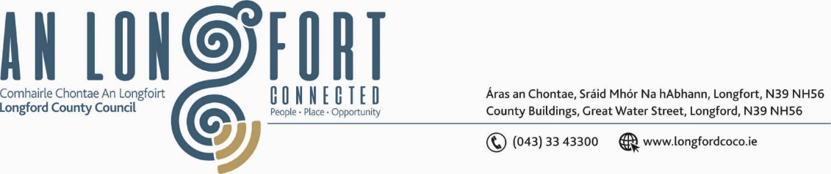

**GRANARD MUNICIPAL DISTRICT**

***Please note meeting will be held in Granard Library and via Microsoft Team***

**13th October 2021.**

**To: Each Member of Granard Municipal District.**

**Dear Member,**

You are requested to attend a Meeting of Granard Municipal District to be held

**Granard Library and via Microsoft Teams** on **Tuesday 26th October, 2021 at 3.30pm** to transact business, as set out on the Agenda hereunder.

**Yours sincerely**,

Ann Marie Mc Keon

______________________

**Ann Marie Mc Keon,**

**Meetings Administrator.**

**AGENDA**

Prayer before meeting.

**1.** Consideration of 2022-2024 Multi-Annual Restoration Improvement Programme.

**2.** Consideration of the 2022 General Municipal Allocation.